Prototype Design Pattern — LLD + Code — Complete Notes

Introduction
The Prototype Design Pattern is a creational pattern that solves a very specific problem: when creating an object is expensive, don't create it repeatedly — clone an existing one instead.
Key insight: Many languages already support this (Java's Cloneable, C++ copy constructors) — you may have used it without knowing it's a design pattern, just like iterators.

The Problem — Expensive Object Creation

Normal Object Creation
cpp
A* obj = new A(); // C++
A obj = new A(); // Java
What happens:
- A chunk of heap memory is allocated
- The constructor runs and initializes fields

The Real Problem: "Expensive" Creation
Some objects are expensive to create because the constructor or initialization involves:
Expensive Operation | Example
Database connection | Opening a connection (takes seconds)
Complex calculations | Heavy computation to derive field values
Loading complex files | Reading large config/template files
Network requests | Fetching configuration from a remote source
Cost here = time (and often memory).
If one object takes 2–3 seconds to create, and you need 100 of them, that's 200–300 seconds of wasted time — plus repeated expensive operations.

The Prototype Solution

Core Idea
- Create the object once (pay the expensive cost once)
- For additional objects, clone the existing one — copying values is cheap
- Don't re-run the expensive constructor path

Benefits
Aspect | Without Prototype | With Prototype
Object creation cost | Paid n times | Paid once, then cloned
Database queries | n queries | 1 query + copies
Complex calculations | n times | Once
Time | High | Much lower
Memory overhead | Repeated allocations | Simpler copies
Key constraint: This works best when objects are similar (few differences) — exactly the case for NPCs, spam emails, template documents, etc.

Real-World Example — NPC Characters

What Are NPCs?
NPC = Non-Player Character — computer-generated characters in games:
- GTA pedestrians walking around
- Enemies in shooter games
- Background characters in RPGs
Characteristics:
- Many NPCs look almost identical
- Very few properties differ between them (name, maybe health/attack/defense)
- Creating one NPC can be expensive (loading textures, DB reads, complex setup)

The Solution
- Create the first NPC with the expensive constructor
- For all subsequent NPCs, clone the first NPC
- Optionally adjust minor properties via setters

Copy Constructor — The Underlying Mechanism
The Prototype pattern is built on the copy constructor concept.

Three Types of Constructors
Type | Signature | Purpose
Default constructor | A() | No arguments; basic init
Parameterized constructor | A(int a, int b) | Takes arguments
Copy constructor | A(const A& other) / A(A other) | Creates a copy from another instance

Copy Constructor Signature
cpp
// C++
A(const A& other) { ... }
java
// Java (conceptual)
public A(A other) { ... }
Job: Copy all field values from other into this.

Why Copy Constructor Is Cheap
- No new operator (in the logical sense)
- No expensive initialization — no DB calls, no complex calculations
- Just direct field-by-field copying
- Fast — O(number of fields) work, all in-memory

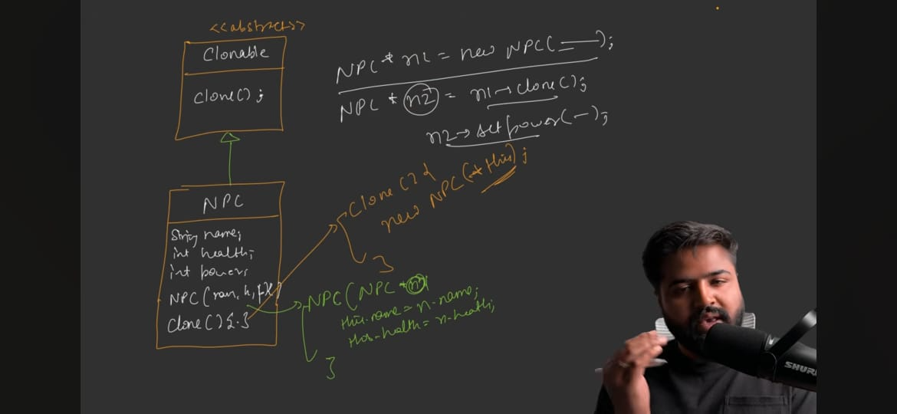

UML Design

Structure
text
┌──────────────────┐
│ «abstract» │
│ Cloneable / │
│ Prototype │
├──────────────────┤
│ + clone() │
└────────┬─────────┘
▲
│ implements
│
┌────────┴─────────┐
│ ConcretePrototype│
│ (e.g., NPC) │
├──────────────────┤
│ - name │
│ - health │
│ - attack │
│ - defense │
├──────────────────┤
│ + NPC(regular) │
│ + NPC(NPC other) │ ← Copy constructor
│ + clone() │
│ + describe() │
│ + setters │
└──────────────────┘
▲
│ has-a reference
│
┌────────┴─────────┐
│ Client │
├──────────────────┤
│ + execute(P) │
└──────────────────┘

Key Classes

Cloneable / Prototype (Abstract)
- Pure abstract class (interface in Java)
- Single method: clone() returning Cloneable* (or Prototype*)
- Marker interface — its only job is to indicate that inheriting classes can be cloned
Naming note: Can be called Cloneable (descriptive) or Prototype (pattern name). Java has a built-in Cloneable marker interface.

ConcretePrototype / NPC
Fields (example):
- string name
- int health
- int attack
- int defense
Constructors:
- Regular constructor — expensive; does the real work (DB, calculations)
- Copy constructor — takes const NPC& other and copies fields
Methods:
- clone() — returns a new NPC via the copy constructor
- describe() — for output/debugging
- Setters (for post-clone customization)

Client
- Holds a Cloneable* / Prototype* reference
- execute() method calls p.clone() to get a new object

Relationships
Relationship | Type
Client has-a Cloneable | Uses-relationship
Cloneable ← ConcretePrototype | Inheritance / Implementation
Copy constructor takes ConcretePrototype | Signature-level use

Class-by-Class Detail

Cloneable (Abstract Base)
cpp
class Cloneable {
public:
virtual Cloneable* clone() = 0;
virtual ~Cloneable() {}
};
- Pure virtual method — forces concrete subclasses to implement
- No data — purely a contract/marker
- Marker role: any class inheriting it is understood as "cloneable" (its instances can be cloned)

NPC (Concrete Prototype)

Fields
cpp
class NPC : public Cloneable {
string name;
int health;
int attack;
int defense;
public:
// ...
};

Regular (Expensive) Constructor
cpp
NPC(string name, int health, int attack, int defense) {
// In a real scenario:
// - DB connection established
// - Complex calculations performed
// - Files loaded
this->name = name;
this->health = health;
this->attack = attack;
this->defense = defense;
}
Narrative point: Even though the code looks simple here (just 4 fields), imagine it embeds heavy operations — that's the expensive cost being avoided.

Copy Constructor
cpp
NPC(const NPC& other) {
this->name = other.name;
this->health = other.health;
this->attack = other.attack;
this->defense = other.defense;
}
Key: No new operator, no expensive calls — just field-by-field copy.

clone() Method
cpp
Cloneable* clone() override {
return new NPC(*this); // Calls copy constructor via *this
}
What happens:
- new NPC(*this) invokes the copy constructor
- Copy constructor copies fields from this
- Returns a Cloneable* (parent reference)
- Since a child object can be assigned to a parent reference, this works
Note: The word "new" here is legitimate — we're allocating fresh heap memory for the clone. The important point: it does not invoke the expensive regular constructor — it invokes the cheap copy constructor.

describe()
cpp
void describe() {
cout << "Name: " << name << ", Health: " << health
<< ", Attack: " << attack << ", Defense: " << defense << endl;
}
Simple output for demonstration.

Setters
cpp
void setName(string name) { this->name = name; }
void setHealth(int health) { this->health = health; }
void setAttack(int attack) { this->attack = attack; }
void setDefense(int defense) { this->defense = defense; }
Purpose: After cloning, minor changes can be applied via setters (e.g., tweak an NPC's stats to make a "powerful" variant).

Client Usage

Creating the First Object (Expensive)
cpp
NPC* alien = new NPC("Alien", 30, 5, 2); // Expensive — pays cost once
alien->describe();

Cloning Subsequent Objects (Cheap)
cpp
// Simple clone — exact same values
NPC* alienCopy = dynamic_cast<NPC*>(alien->clone());
alienCopy->describe();
dynamic_cast: Required because clone() returns Cloneable* (parent) and we need NPC* (child) to use NPC-specific methods.

Cloning + Customizing
cpp
NPC* powerfulAlien = dynamic_cast<NPC*>(alien->clone());
powerfulAlien->setName("Powerful Alien");
powerfulAlien->setHealth(50);
powerfulAlien->setAttack(35);
powerfulAlien->setDefense(5);
powerfulAlien->describe();
Flow:
- Clone — all values copied
- Setters — tweak the few values that differ
- That's it — no expensive constructor involved

Shallow Copy vs Deep Copy (Critical Concept)

Why It Matters
The copy constructor works fine for primitive fields (int, string — string is effectively value-like for this purpose). But it breaks for non-primitive fields (pointers, references to other objects).

Shallow Copy
Definition: Copy only the references — the new object points to the same heap data as the original.
Example (bad for non-primitives):
cpp
class NPC {
int x, y; // primitives — copy fine
Student* s1; // reference to Student object
};

NPC(const NPC& other) {
this->x = other.x; // ✓ copies value
this->y = other.y; // ✓ copies value
this->s1 = other.s1; // ✗ copies pointer (not object!)
}
Problem: Both original.s1 and clone.s1 point to the same heap memory. Changing data through one affects the other.
When primitives only — shallow copy is fine, because primitives are stored by value (each instance has its own copy).

Deep Copy
Definition: Recursively copy all nested objects to independent memory — no sharing.
Example (correct for non-primitives):
cpp
NPC(const NPC& other) {
this->x = other.x;
this->y = other.y;
this->s1 = new Student(*other.s1); // new heap memory, deep copy
}
Result: original.s1 and clone.s1 point to different heap memory. Independent.

Summary Table
Aspect | Shallow Copy | Deep Copy
Primitives | Copies value ✓ | Copies value ✓
References/pointers | Copies pointer — shares data | Allocates new memory — independent
Safety | Unsafe if nested objects exist | Fully independent
Cost | Cheaper | More expensive
When to use | All-primitive classes | Classes with nested references
Design implication: For NPCs with only primitives (name, health, attack, defense), shallow copy suffices. If NPC has a Weapon* or Armor* reference, you must deep copy those.

Code Walkthrough — Without Prototype (The Bad Way)

Setup
cpp
NPC* alien = new NPC("Alien", 30, 5, 2);
alien->describe();

NPC* powerfulAlien = new NPC("Powerful Alien", 30, 5, 5); // Full new construction
powerfulAlien->describe();
Problem: Only name and defense changed — yet the entire expensive constructor ran for powerfulAlien.

With 100 Aliens
- 100 × new NPC(...) calls
- 100 × expensive initialization
- 100 × DB queries / complex calculations
- Massive wasted time and memory
Code…..see Notes, WithoutPrototype, WithPrototype

Code Walkthrough — With Prototype (The Good Way)

Setup
cpp
NPC* templateAlien = new NPC("Alien", 30, 5, 2); // Expensive — once
templateAlien->describe();

NPC* alienCopy = dynamic_cast<NPC*>(templateAlien->clone());
alienCopy->describe();

NPC* powerfulAlien = dynamic_cast<NPC*>(templateAlien->clone());
powerfulAlien->setName("Powerful Alien");
powerfulAlien->setHealth(50);
powerfulAlien->setAttack(35);
powerfulAlien->setDefense(5);
powerfulAlien->describe();
Flow:
- One expensive new NPC(...) call
- N cheap clone() calls
- Minor tweaks via setters

Sample Output
text
Setting up template NPC: Alien
Cloning NPC: Alien
Name: Alien, Health: 30, Attack: 5, Defense: 2
Cloning NPC: Alien
Name: Powerful Alien, Health: 50, Attack: 35, Defense: 5
Clean UML:-
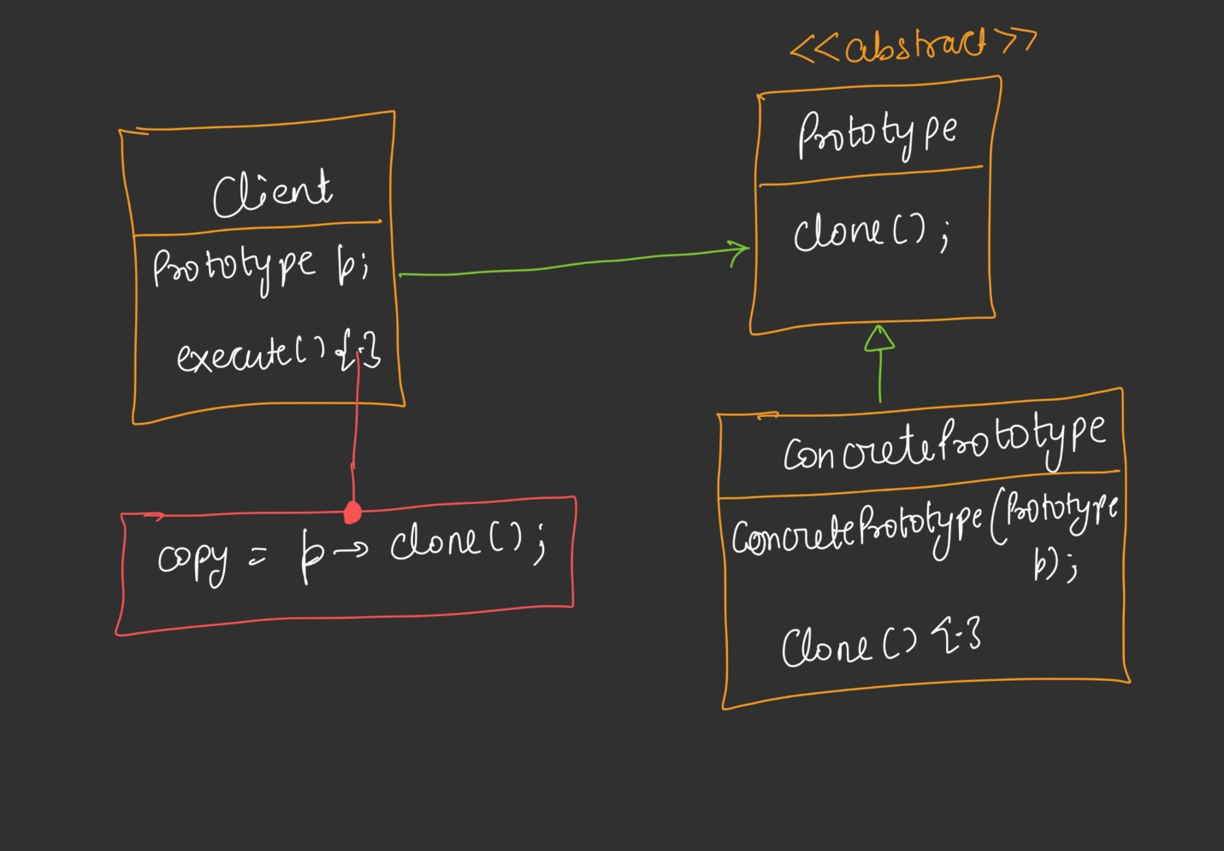

When to Use / When Not to Use Prototype

When It Shines
Scenario | Why
NPCs in games | Many similar small objects; expensive to instantiate
Enemy waves | Same template, minor variations
Document templates | Clone a template, then customize
Configuration objects | Load once, clone many
Spam email generation | Small variations of a base email
Any "many similar objects, expensive to create" | Clone is always cheaper

When It Doesn't Fit
Scenario | Why Not
Objects have vastly different values | Would need to change all fields via setters — no benefit
Object has no expensive creation | Regular new is just as fast
Objects have complex mutable state that diverges immediately | Deep copy cost may exceed construction cost
Every instance is truly unique | Cloning doesn't save anything
Rule of thumb: Prototype is useful when objects are highly similar with few differences.

Standard UML Diagram — Full View
text
┌─────────────┐
│ Client │
├─────────────┤
│ + execute() │
└──────┬──────┘
│ has-a (Prototype*)
▼
┌──────────────────┐
│ «abstract» │
│ Prototype │
│ (Cloneable) │
├──────────────────┤
│ + clone() : * │
└────────┬─────────┘
▲
│ inherits
│
┌────────┴─────────┐
│ ConcretePrototype│
├──────────────────┤
│ - fields... │
├──────────────────┤
│ + Concrete │
│ Prototype(...) │
│ + Concrete │
│ Prototype( │ ← Copy constructor
│ ConcreteProto- │
│ type&) │
│ + clone() │
└──────────────────┘

Key relationships
- Client → Prototype (has-a, uses)
- Prototype ← ConcretePrototype (inheritance)
- ConcretePrototype has-a copy constructor of its own type
- clone() returns a Prototype* (parent reference) pointing to a new ConcretePrototype

Standard Definition
"The Prototype pattern lets you create new objects by copying or cloning another instance."

Breakdown
- "Create new objects" — you get a distinct object in memory
- "By copying or cloning" — using the copy constructor, not the expensive regular constructor
- "Another instance" — the "template" or "prototype" object
- Avoids repeatedly calling the expensive new X(...) path

Real-World Use Cases
Use Case | Details
Game development (NPCs) | The canonical example — many similar characters
Enemy waves/spawns | Clone a base enemy, tweak stats per wave
Document templates | Clone a template doc, customize per user
Configuration loading | Load expensive config once, clone for threads
Spam/marketing emails | Base email cloned with per-recipient tweaks
GUI widget creation | Clone a pre-configured widget (with styles attached)
Caching/snapshots | Capture object state and restore later
General rule: Use when many objects share most of their state, and creation is expensive.

Key Interview Points
- Why Prototype? — Avoid expensive repeated construction
- How does it work? — Copy constructor + a clone() method
- What's the marker interface? — Cloneable — no methods actually invoked by it in some languages (like Java); or a pure abstract class with clone() (C++)
- Cloneable vs copy constructor — Copy constructor is the underlying primitive; clone() wraps it in polymorphism
- dynamic_cast requirement — clone() returns parent type; dynamic_cast retrieves the child type
- Shallow vs Deep copy — Critical distinction; shallow shares nested references, deep copies them
- When not to use — Highly dissimilar objects; cheap creation
- Prototype vs Factory vs Builder — Factory/Builder construct from scratch; Prototype copies an existing instance
- Best real-world scenario — NPCs in games, template documents
- Design intent — Performance + memory efficiency for similar objects

Comparing Prototype with Related Patterns
Pattern | Focus
Factory | Create one object of a type, hide construction logic
Builder | Step-by-step construction of a complex object
Prototype | Clone an existing object instead of constructing
Singleton | Ensure only one instance exists
When comparing in interviews: Prototype is the only creational pattern that creates from an existing object, not from scratch.

Code Reference — Complete NPC Class
cpp
#include <iostream>
#include <string>
using namespace std;

class Cloneable {
public:
virtual Cloneable* clone() = 0;
virtual ~Cloneable() {}
};

class NPC : public Cloneable {
string name;
int health, attack, defense;
public:
// Expensive constructor
NPC(string name, int health, int attack, int defense) {
// Imagine: DB connection, complex calculations...
this->name = name;
this->health = health;
this->attack = attack;
this->defense = defense;
cout << "Expensive NPC created: " << name << endl;
}

// Copy constructor (cheap)
NPC(const NPC& other) {
this->name = other.name;
this->health = other.health;
this->attack = other.attack;
this->defense = other.defense;
}

// Clone
Cloneable* clone() override {
return new NPC(*this); // Uses copy constructor
}

// Setters for post-clone customization
void setName(string n) { name = n; }
void setHealth(int h) { health = h; }
void setAttack(int a) { attack = a; }
void setDefense(int d) { defense = d; }

void describe() {
cout << "NPC: " << name
<< " | HP: " << health
<< " | ATK: " << attack
<< " | DEF: " << defense << endl;
}
};

int main() {
NPC* templateNPC = new NPC("Alien", 30, 5, 2);
templateNPC->describe();

NPC* copy1 = dynamic_cast<NPC*>(templateNPC->clone());
copy1->describe();

NPC* copy2 = dynamic_cast<NPC*>(templateNPC->clone());
copy2->setName("Powerful Alien");
copy2->setHealth(50);
copy2->setDefense(5);
copy2->describe();

delete templateNPC;
delete copy1;
delete copy2;
return 0;
}

One-Line Summary
Prototype solves the "expensive-to-create" problem by cloning an existing object via its copy constructor, avoiding expensive DB calls/calculations/computation — perfect for games with many similar NPCs, document templates, and any scenario with many similar objects.

